Formula 1 project:

1. Ingestion of file
2. Created the containers in azure data lake storage gen 2
3. Uploaded files manually
4. Mounted the storage account in the databricks :  
   stored credentials(client_id,tenant_id,secret_key) of storage account

Defined function to mount the storage accounts using the credentials

By passing source and mount point we can mount the storage account

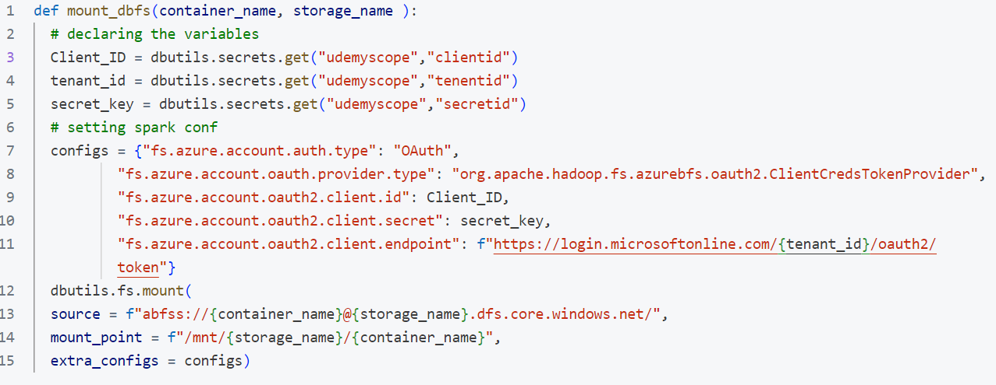

1. Defined schema for the file:
2. Read the file :
3. After reading the file column renaming did
4. Best_practices: adding current_timestamp(), source of the file column: took these parameters from the user
5. Write the file as delta table and partition if required
6. Incremental file handling:  
   I used the merge method to load the data to the target

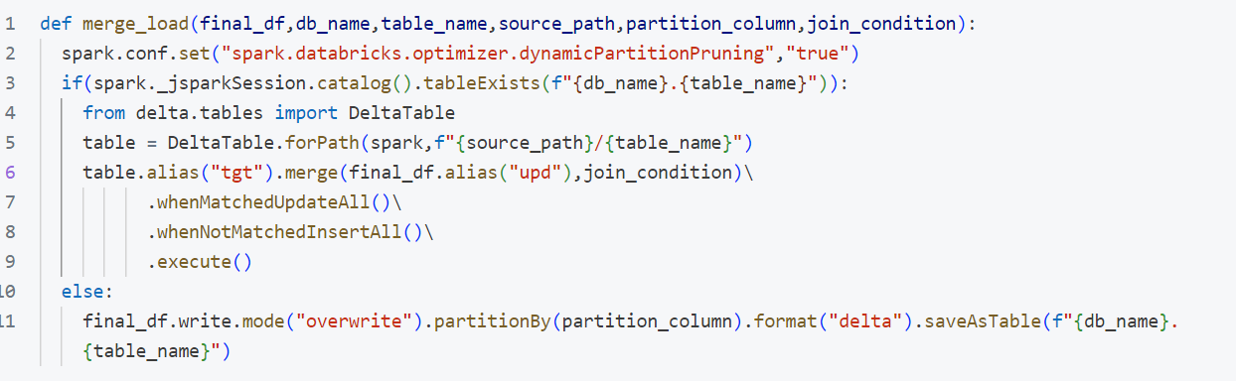

1. Then I build some insights for driver and teams
2. I got to know how the files will be stored, how the metadata will be store for delta table all these things I got to know
3. Then I build the ADF pipeline to run all these notebooks I created
4. Triggerd the pipeline using the task